Assignment Day 1
DSA

Name : Abhinay Kumar
PRN : 260240120005
Form No : 251201864
Course : PGCP - AC
Batch : February 2026

Q1. Implement following function to delete element from specified position in given array.
The function should return the updated logical size of array.
int deleteFromPosition(int[] arr, int n, int pos);

import java.util.Arrays;

public class Q1_DeleteElement {

// Function to delete element from specified position in given array
public static int deleteFromPosition(int[] arr, int n, int pos) {
if (pos < 0 || pos >= n) {
System.out.println("Invalid position");
return n;
}
for (int i = pos; i < n - 1; i++) {
arr[i] = arr[i + 1];
}
return n - 1;
}

public static void main(String[] args) {
int[] arr = {10, 20, 30, 40, 50, 0, 0}; // Output array with extra capacity
int logicalSize = 5;

System.out.println("Original array: " + Arrays.toString(Arrays.copyOf(arr, logicalSize)));
System.out.println("Original logical size: " + logicalSize);

int deletePos = 2; // Delete element '30'
logicalSize = deleteFromPosition(arr, logicalSize, deletePos);

System.out.println("\nAfter deleting element at position " + deletePos + ":");
System.out.println("Updated array: " + Arrays.toString(Arrays.copyOf(arr, logicalSize)));
System.out.println("Updated logical size: " + logicalSize);
}
}

OUTPUT :

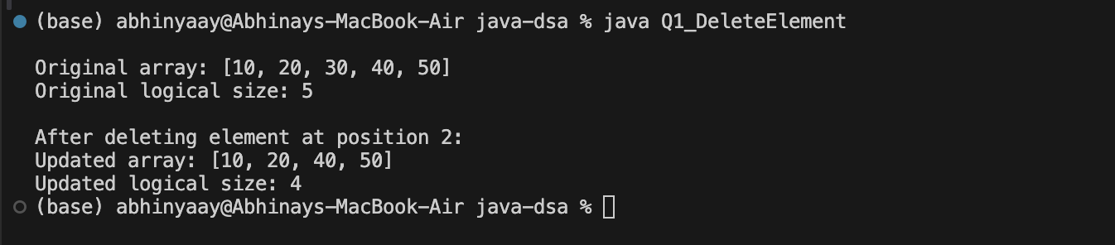

Q2. Implement a Stack class using resizable array that implements the Stack interface defined in class.
Throw appropriate exception when required.

Stack.java

// Removed package declaration for easier running

public interface Stack {
void push(int element);
int pop();
boolean isEmpty();
boolean isFull();
}

Q2_ResizableStack.java

public class Q2_ResizableStack implements Stack {
private int[] stackData;
private int top;

public Q2_ResizableStack(int initialCapacity) {
stackData = new int[initialCapacity];
top = -1;
}

@Override
public void push(int element) {
if (isFull()) {
System.out.println("Stack is full, resizing...");
resize();
}
top = top + 1;
stackData[top] = element;
}

@Override
public int pop() {
if (isEmpty()) {
throw new RuntimeException("Stack Underflow: Stack is empty");
}
int result = stackData[top];
top = top - 1;
return result;
}

@Override
public boolean isEmpty() {
return top == -1;
}

@Override
public boolean isFull() {
return top == (stackData.length - 1);
}

private void resize() {
int newCapacity = stackData.length * 2;
if (newCapacity == 0) {
newCapacity = 1;
}
int[] newArray = new int[newCapacity];

for (int i = 0; i <= top; i++) {

}
stackData = newArray;
}

public static void main(String[] args) {
System.out.println("Testing Resizable Stack:");
Q2_ResizableStack stack = new Q2_ResizableStack(2);

stack.push(10);

System.out.println("Pushed 10, 20. Is the stack full? " + stack.isFull());

stack.push(30); // Should trigger resize

System.out.println("Popped: " + stack.pop());

System.out.println("Popped: " + stack.pop());

try {

} catch (RuntimeException e) {
System.out.println("Exception caught correctly: " + e.getMessage());
}
}
}

OUTPUT :

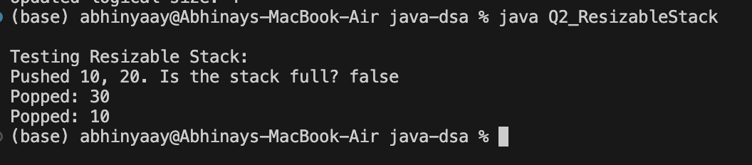

Q3. Define Queue as ADT (Refer to class notes).

public interface Q3_QueueADT<T> {
void enqueue(T element);
T dequeue();
T peek();
boolean isEmpty();
boolean isFull();
int size();
}

Q4. Implement a Generic Queue class using array that implements the Queue interface defined in Q1.
Throw appropriate exception when required.
(Refer to class notes)

public class Q4_GenericQueue<T> implements Q3_QueueADT<T> {
private Object[] queueData;
private int front;
private int rear;
private int size;
private int capacity;

public Q4_GenericQueue(int capacity) {
this.capacity = capacity;
this.queueData = new Object[capacity];
this.front = 0;
this.rear = -1;
this.size = 0;
}

@Override
public void enqueue(T element) {
if (isFull()) {
throw new RuntimeException("Queue Overflow: The queue is full");
}
rear = (rear + 1) % capacity;
queueData[rear] = element;
size++;
}

@Override
@SuppressWarnings("unchecked")
public T dequeue() {
if (isEmpty()) {
throw new RuntimeException("Queue Underflow: The queue is empty");
}
T element = (T) queueData[front];
queueData[front] = null; // facilitate garbage collection
front = (front + 1) % capacity;
size--;
return element;
}

@Override
@SuppressWarnings("unchecked")
public T peek() {
if (isEmpty()) {
throw new RuntimeException("Queue Underflow: The queue is empty");
}
return (T) queueData[front];
}

@Override
public boolean isEmpty() {
return size == 0;
}

@Override
public boolean isFull() {
return size == capacity;
}

@Override
public int size() {
return size;
}

public static void main(String[] args) {
System.out.println("Testing Generic Queue (Capacity: 3)");
Q4_GenericQueue<String> queue = new Q4_GenericQueue<>(3);

queue.enqueue("First");
queue.enqueue("Second");
queue.enqueue("Third");

System.out.println("Queue size: " + queue.size());

try {
queue.enqueue("Fourth"); // Should throw exception
} catch (RuntimeException e) {
System.out.println("Exception caught correctly: " + e.getMessage());
}

System.out.println("Dequeued: " + queue.dequeue());
System.out.println("Dequeued: " + queue.dequeue());

queue.enqueue("Fourth"); // Circular wrap-around
System.out.println("Dequeued: " + queue.dequeue());
System.out.println("Dequeued: " + queue.dequeue());

try {
queue.dequeue(); // Should throw exception
} catch (RuntimeException e) {
System.out.println("Exception caught correctly: " + e.getMessage());
}
}
}

OUTPUT :

